# Screenshots – How to use

Copy the executable to a folder on disk.

## Receive data

Open command prompt and change current directory to directory where you copied these executable files.

At the command prompt type:

MulticastReceive.exe –h

and press <Return>

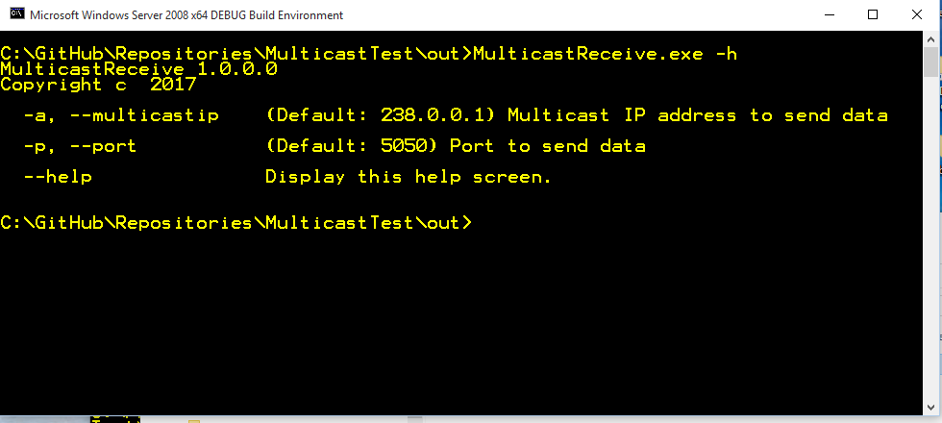

You will get output of help screen usage.

As you see, from the help screen, if you start program without any parameters, program will be start to listen for multicast IP network traffic on IP address 238.0.0.1 and port 5050.

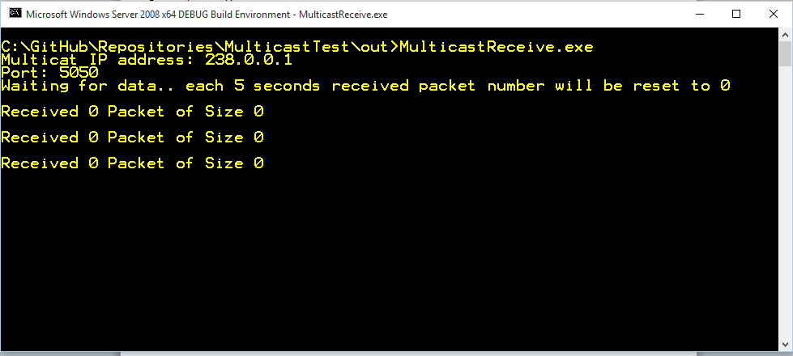

Each 5 second program will display statistic for received packet on listen multicast IP address and port.

In this case that will be IP=238.0.0.1 and port=5050

For example if you wish to start program to listen for multicast IP traffic on IP address 224.0.0.1 and port 5000, you will use the following syntax:

MulticastReceive.exe -a 224.0.0.1 -p 5000

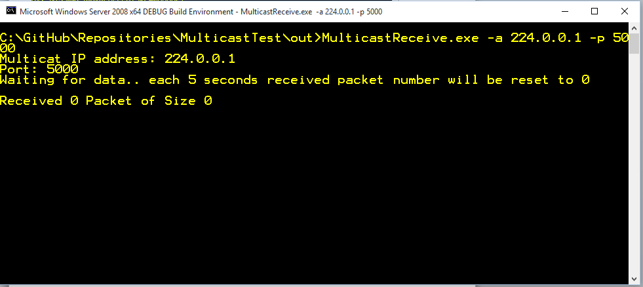

After execution, program will continue to listen for network traffic on IP address and port.

To stop program execution, press CTRL+C on the command prompt.

## Send data (generate multicast IP traffic)

Open command prompt and change current directory to directory where you copied these executable files.

At the command prompt type:

MulticastSend.exe –h

and press <Return>

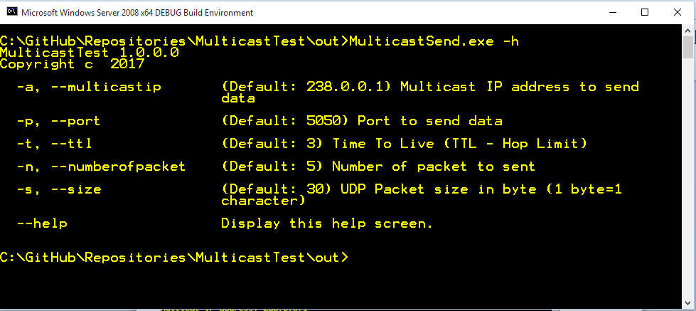

You will get output of help screen usage.

As you see, from the help screen, if you start program without any parameters, program will be start to send multicast IP packet to IP address 238.0.0.1, port 5050, with maximum Hop Limit of 5, 5 packet with size of 30 characters each.

For example if you wish to start program to send multicast IP traffic to IP address 224.0.0.1, port 5000, with 3 hop limit, 10 packet with size of 128 characters, you will use the following syntax:

MulticastSend.exe -a 224.0.0.1 -p 5000 –t 3 –n 10 –s 128

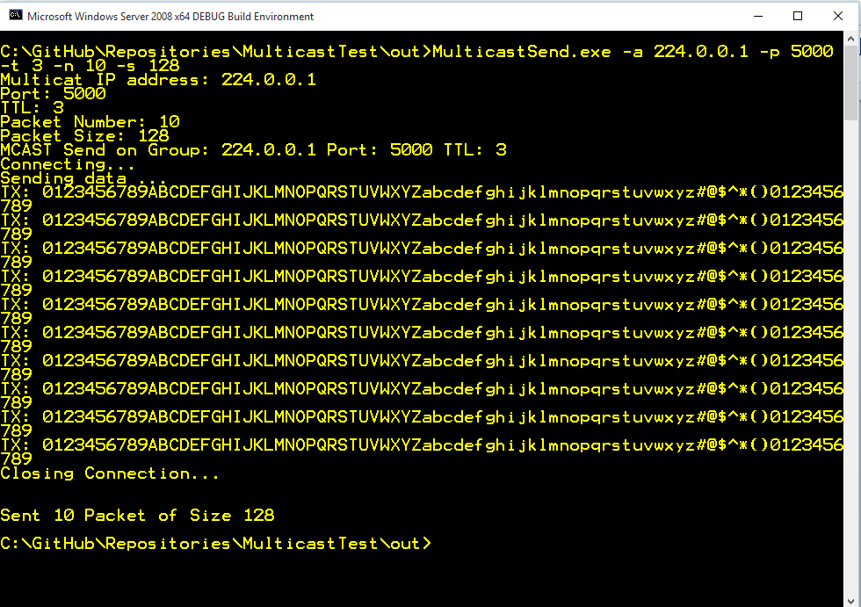

After execution program will exit to command prompt.

## Test Example

To test multicast IP network traffic on IP address 224.0.0.1 and port 5000, we need to use the following syntax:

For receiving data:

MulticastReceive.exe -a 224.0.0.1 -p 500

MulticastSend.exe -a 224.0.0.1 -p 5000 –t 3 –n 5 –s 10

MulticastReceive - screen

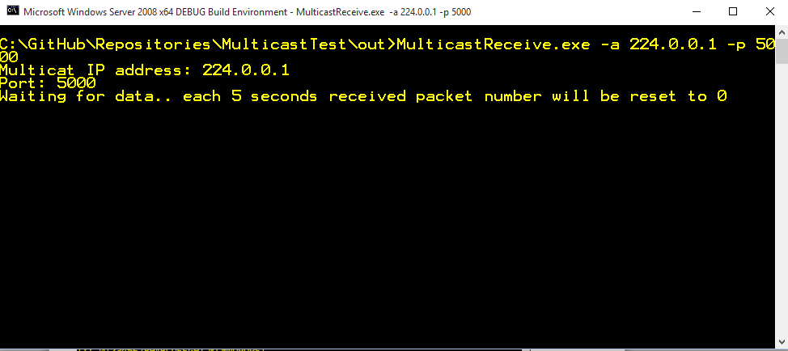

MulticastSend - screen

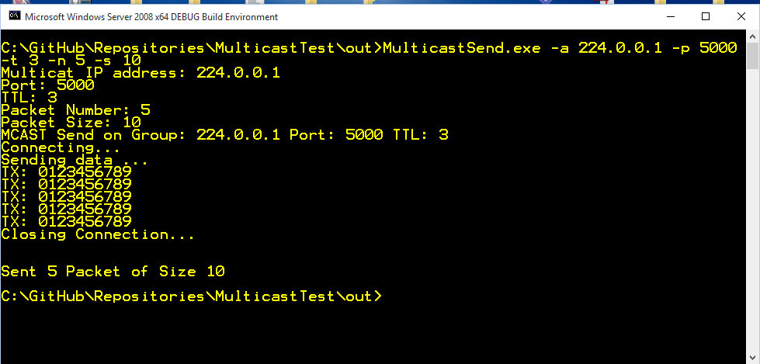

After execute MulticastSend program, on MulticastReceive program, you will get the following output

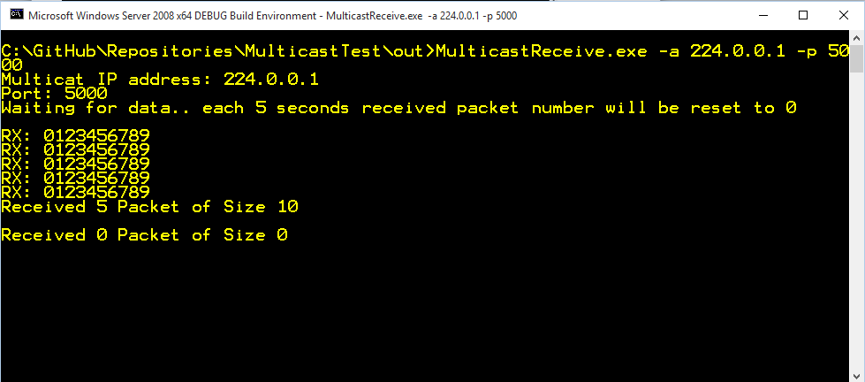

To stop MulticastRecive program, press CTRL+<C> on the command prompt screen

